Sir/ Madam:

Greetings!

I am college graduate of Bachelor of Science in Information Technology at Salazar Colleges of Science Institute and Technology. It is my first time to apply in this job and I am willing to attend training to enhance my skills.

I have attached my resume for further details about myself. I would appreciate the opportunity to discuss my qualification for this position in greater detail with you in person at your earliest convenience.

I am looking forward to be part of your company.

Respectfully Yours,

BRIAN A. LOCAYLOCAY

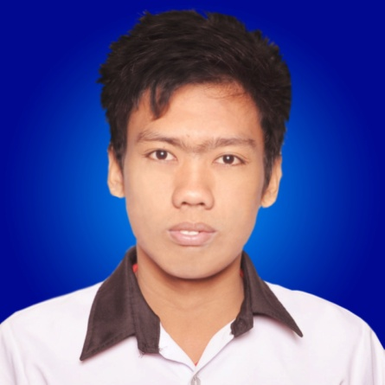

**LOCAYLOCAY, BRIAN A.**

**Cellphone #:** 09309897249 or 09331492729

**Email address:** breyjhan@gmail.com

**Address:** J.D Villacarlos St. Talangnan, Madridejos, Cebu

**OBJECTIVES**

To find a job which offers me to learn more skills and develop within the company as web designer or web programmer or a graphics designer.

**PERSONAL DATA**

Age : 21 years old

Birth date : November 07, 1992

Place of Birth : Talangnan, Madridejos, Cebu

Sex : Male

Civil Status : Single

Citizenship : Filipino

Height : 5’5”

Religion : Roman Catholic

Language Spoken : Bisaya, Cebuano, Tagalog, English

**EDUCATIONAL ATTAINMENT**

TERTIARY : Salazar Colleges of Science & Institute of Tech.

211 N. Bacalso Ave., Cebu City

2013 - 2014

SECONDARY : The Sisters of Mary School Boystown

Tungkop, Minglanilla, Cebu

2009-2010

ELEMENTARY : Madridejos Central School

Poblacion, Madridejos, Cebu

2005-2006

**SEMINARS ATTENDED**

9th PSITE 7 ICT STUDENT CONGRESS : CIT-University

Cebu City

March 5, 2013

10th PSITE 7 ICT STUDENT CONGRESS : University of San Carlos

Cebu City

March 7, 2014

IT SEMINAR 2013 : Fundamentals Laboratory Bldg.

SCSIT – Main Campus

Cebu City

September 14, 2013

**ACHIEVEMENTS**

` ACADEMIC EXCELLENCE AWARD SCSIT – Main Campus

Cebu City

March 19, 2013

CERTIFICATE OF APPRECIATION SCSIT – Main Campus

Cebu City

March 19, 2013

**Technical Skills**

`Software : Adobe Photoshop, Adobe Dreamweaver, SQL Server(Xampp).

Microsoft applications (msword, publisher and etc.)

Programming language: HTML, PHP, CSS and Javascript.

**JOB EXPERIENCE**

SCSIT – Main campus EDP staff

June 2013- April 2014

**REFERENCES**

MR. EFFIE HUBAHIB Web developer / Instructor

SCSIT

09434003807

DR. ROGER SALDIA Computer Studies Dean

SCSIT

09328771765